# Right Way to add image in React JS Project

* Import image in JS file

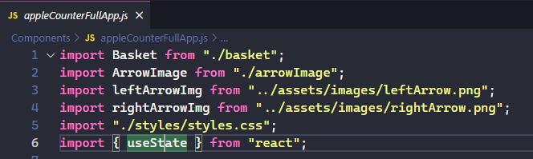

* Use it  
  